Objectives:

* Creating Lists, adding & removing items from a list, sum and average numbers from a list.
* Creating List Boxes using Tkinter

Please submit this document for grading when completed… Please work in-groups.

**There are 5 Challenge Exercises, each worth 20%**

Tuples are **used to store multiple items in a single variable**.

**Project #1** (creating lists). A list is a container that can hold character or number values. Instead of having to declare multiple variables, we can use one variable and assign multiple parameters.

Specifying which number in a list to print using indexes, notice the 0-index pointing to the number 2.

|  |
| --- |
| Values = 2 4 6 8 10 |
| Indexes = 0 1 2 3 4 |
|  |

Sum the list of numbers using a for loop

**Project #2** (creating lists, with input values and outputting the list to a text file)

Pass the name to the list

**Project #3** (creating list box using Tkinter)

**Challenge Exercise #1: add your three favorite food items to the list box.**

**#1 print screen the running application with code below here.**

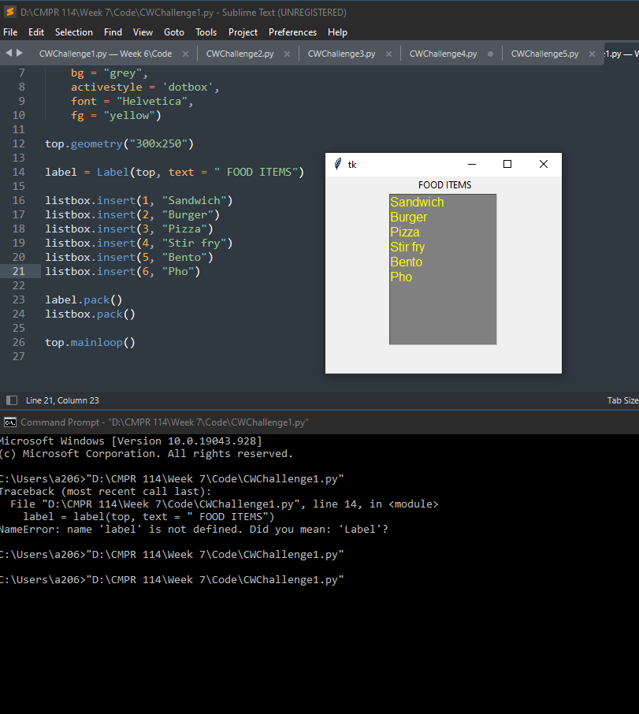

**Project #4** (creating list box using Tkinter and Selecting from it)

**Challenge Exercise #2:** continuing with project #3, print the food items.

**#2 print screen the running application with code below here.**

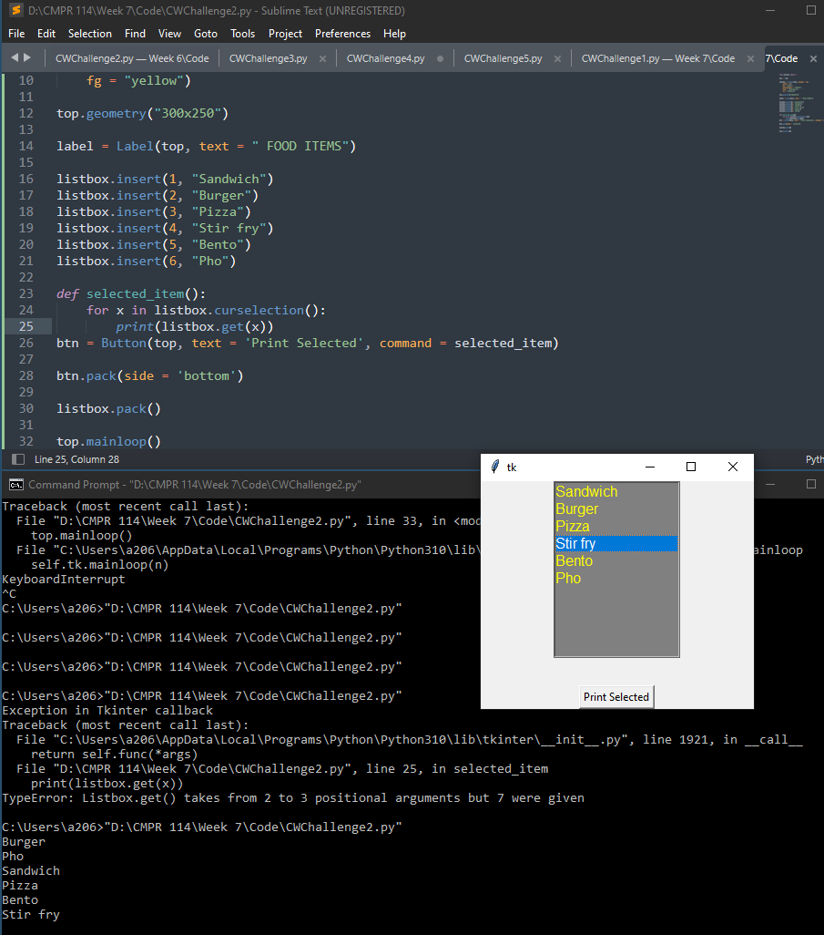

**Project #5:** *Replacing* an old item in a list with a new item

**Project #6:** This program will demonstrate how to insert and remove items in a list, and total and average number of items in a list.

**Challenge Exercise #3:** continuing with project #6, the total function, output the numbers list to a text file.

**#3 print screen the running application with code below here.**

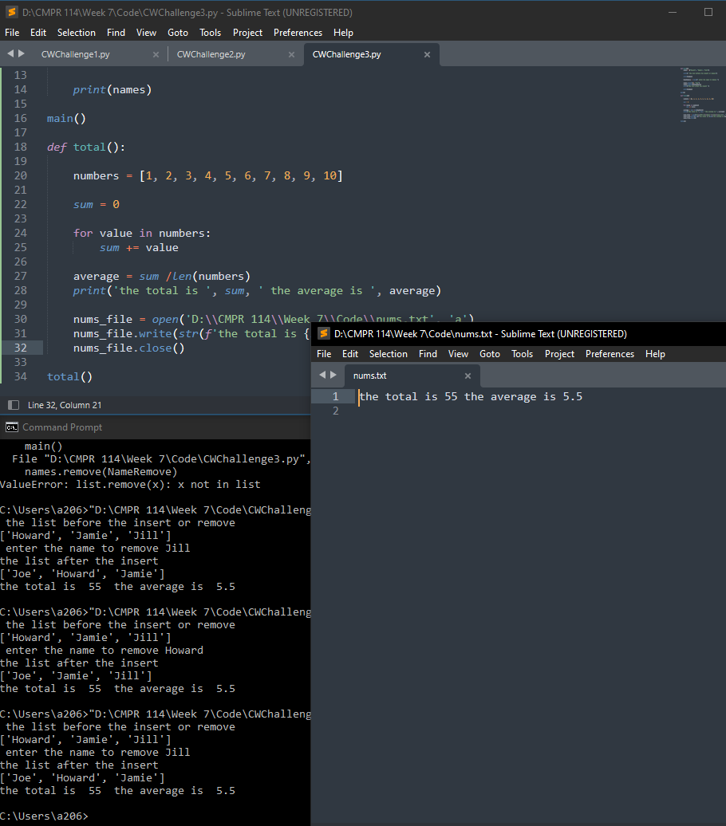

**Challenge Exercise #4:** TOTAL SALES APP: Design a program that asks the user to enter a store’s sales for each day of the week. The amount should be stored in a list. Use loop to calculate the total sales for the week and display the result. Plus output the results into a text file as well as the console.

**#4 print screen the running application with code below here.**

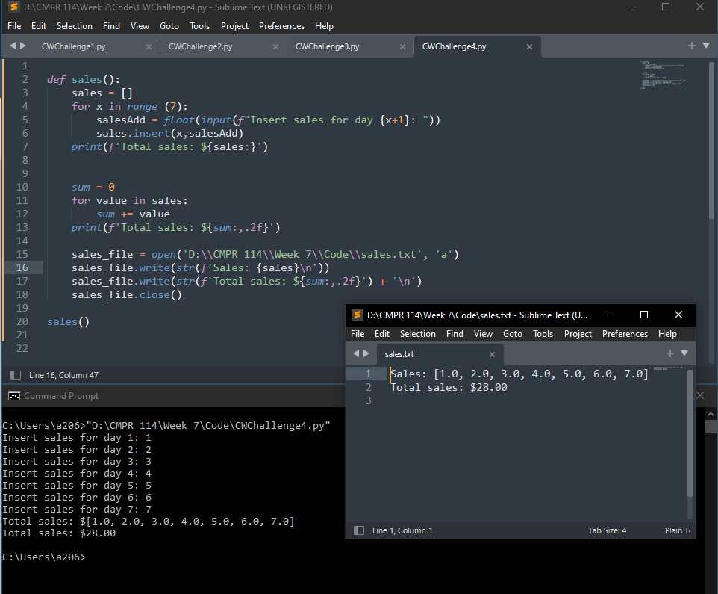

**Challenge Exercise #5:** RAINFALL APP: Design a program that let’s the user to enter the total rainfall for each of the 12 months into a list. The program should calculate and display the total rainfall for the year, the average monthly rainfall, the months with the highest and lowest amounts of rainfall. Plus output the results into a text file as well as the console.

**#5 print screen the running application with code below here.**

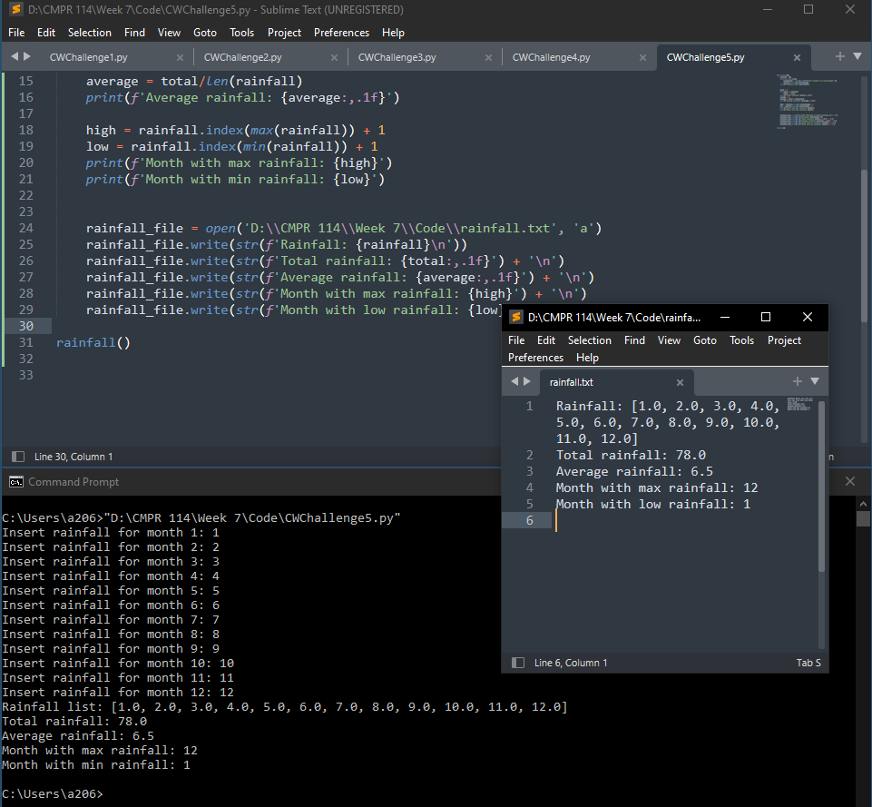

**Submit this document to Module 7 Class Exercise #6**